**Exercises: Linear-Data-Structures**

This document defines the lab for ["Data Structures – Fundamentals (Java)" course @ Software University](https://softuni.bg/trainings/2812/data-structures-fundamentals-with-java-march-2020). Please submit your solutions (source code) of all below described problems in [Judge](https://judge.softuni.bg/Contests/2038/02-Linear-Data-Structures-Exercises).

Write Java code for solving the tasks on the following pages. Code should compile under the Java 8 and above standards you can write and locally test your solution with the Java 13 standard, however **Judge will run the submission with Java 10 JRE**. Avoid submissions with **features included after Java 10** release doing **otherwise** will result in **compile time error**.

Any code files that are part of the task are provided as **Skeleton**. In the beginning import the project skeleton, do not change any of the interfaces or classes provided. You are free to add additional logic in form of methods in both interfaces and implementations you are not allowed to delete or remove any of the code provided. Do not change the names of the files as they are part of the tests logic. **Do not change the packages** or move any of the files provided inside the skeleton if you have to add new file add it in the same package of usage.

Some **tests may be provided** within the skeleton – use those for local **testing and debugging**, however there **is no guarantee that there are no hidden tests added inside Judge**.

Please follow the exact instructions on uploading the solutions for each task. Submit as **.zip archive** the files contained inside **"...\src\main\java"** folder this should work for all tasks regardless of current DS implementation.

In order for the solution to compile the tests **successfully** the project **must** have **single** **Main.java** file containing single **public static void main(String[] args)** method even empty one within the **Main class**.

Some of the problem will have simple **Benchmark** **tests** inside the skeleton. You can try to run those with **different** **values** and **different** **implementations** in order to **observe** behaviour. However **keep** in mind that the result comes **only as numbers** and this data may be **misleading** in some situations. Also the tests are not started from the command prompt which may **influence** the **accuracy** of the results. Those tests are only added as an **example** of **different** **data** **structures** **performance** on their **common** operations.

The Benchmark tool we are using is **JMH** (Java Microbenchmark Harness) and that is Java harness for building, running, and analyzing, **nano/micro/milli/macro** benchmarks written in Java and other languages targeting, the JVM.

**Additional** **information** can be found here: [JMH](https://openjdk.java.net/projects/code-tools/jmh/) and also there are other examples over the **internet**.

**Important:** when importing the skeleton **select** **import** **project** and then **select** **from** **maven** **module**, this way any following **dependencies** will be **automatically** **resolved**. The project has **NO** **default** **version** of **JDK so after the import you may (depends on some configurations) need to specify the SDK, you can download** **JDK 13** from [**HERE**](https://jdk.java.net/13/)**.**

## Faster Queue

You have the basic implementation of the Queue<E> data structure from the lecture lab. The task is simple you have to modify the structure so now we can reduce the complexity when adding to a **constant facto**r.

* **Offer (E element)** – modify thisoperationso you can **perform offer in constant time**, also modify anything required to achieve that.

Hint: you can add additional node that point to the end of the queue. But now you have to modify everything that somehow relates to the node chaining.

Here the tests are hidden so you have to figure out how to solve the problem above. Remember you can use the **benchmark** **tests** to observe the **performance**.

## DoublyLinkedList

Your task is to take the implementation of the SinglyLinkedList<E> form the lab and make it doubly linked list. This means that you have to add two things:

1. Add additional field **Node<E> tail** that will always **point to the last** element of the linked list.
2. Add field **Node<E>** **previous** to the **Node class** this should point to the **previous node**.

Do the changes above the methods below should remain with unchanged erasure, use the tests provided to ensure that.

### AddFirst (E element) – adds an element in front of the collection and increases the size.

### AddLast (E element) – adds an element after the last element of the collection and increases the size.

### E removeFirst () – removes and returns the first element of the collection if there is such if no then throw IllegalStateException with appropriate message.

### E removeLast () – removes and returns the last element of the collection if there is such if no then throw IllegalStateException with appropriate message.

### E getFirst () – returns but does not remove the first element of the collection if there is such if no then throw IllegalStateException with appropriate message.

### E getLast () – returns but does not remove the last element of the collection if there is such if no then throw IllegalStateException with appropriate message.

### Int size () – returns the number of elements inside the collection.

### Boolean isEmpty () – returns if the collection contains any elements or not.

Going on with the changes you will notice that **we do similar operations** every time **we do chaining**. **Change the Node constructor** so its **call does that work** instead of you.

## ArrayDeque – Circular Queue

Implement a data structure ArrayDeque<E> that holds a sequence of elements of generic type E. The structure should have some **capacity** that **grows twice** when it is filled, **always starting with odd number**. This data structure should be usable as **Stack**, **Queue** and **ArrayList** in some manners. Should Support the following operations:

* **Add (E element)** – **adds** an element at the **end**.
* **Offer (E element)** – **adds** an element the same way a **Queue** **does**.
* **AddFirst (E element)** – **adds** an element in **front** of all other elements.
* **AddLast (E element)** – **adds** an element after the **last** **one**.
* **Push (E element)** – **adds** an element the same way a **Stack** **does**.
* **Insert (int index, E element)** – **inserts** an element at given **index** if **valid** if **not** throw **IndexOutOfBounds** exception.
* **Set (int index, E element)** – **sets** an element at given **index** if **valid** if **not** throw **IndexOutOfBounds** exception.
* **Peek ()** – **peeks** an element the same way a **Queue** and a **Stack** do make it **work** for **both** **usages**. If there are **no** **elements** return **null**.
* **Poll ()** – **removes** the element in **front** and **returns** it, if **no** elements are stored return **null**.
* **Pop ()** – **removes** the element at the **end** and **returns** it, if **no** elements are stored return **null**.
* **Get (int index)** – **gets** an element at given **index** if **valid** if not throw **IndexOutOfBounds** exception.
* **Get (Object object)** – **gets** the **first** **occurrence** of an element and **returns** it if there is **no** such element return **null**.
* **Remove (int index)** – **removes** the element at given **index** and **returns** it valid if **no** throw **IndexOutOfBounds** exception.
* **Remove (Object object)** – **removes** the **first** **occurrence** of an element if **present** if not returns **null**.
* **RemoveFirst ()** – **removes** the element in **front** and **returns** it, if **no** elements are stored return **null**.
* **RemoveLast ()** – **removes** the element at the **end** and **returns** it, if **no** elements are stored return **null**.
* **Size ()** – **returns** the **number** of elements stored.
* **Capacity ()** – **returns** the **capacity** of the structure.
* **TrimToSize ()** – **shrinks** the **capacity** to the **number** of elements so the two values become **equal**.
* **IsEmpty ()** – **returns** if there **are** elements present or **no**.

As you can see some methods do pretty much the same thing. So why do we need them? We can make the usage of the data structure much more clear when we read the code that uses its operations if they are well defined. For example if you want to use it as a Stack add by calling **push () or something else** which one of the above methods can cover that case? Think about reusing some parts of the code and mostly think in such a way that it is clear which operation does what without the need to look at the implementation details.

Try to figure out the **similar** operations between this DS and Stack or Queue etc…

**Hints**: **Constructor and fields** made easy so you can start from somewhere:

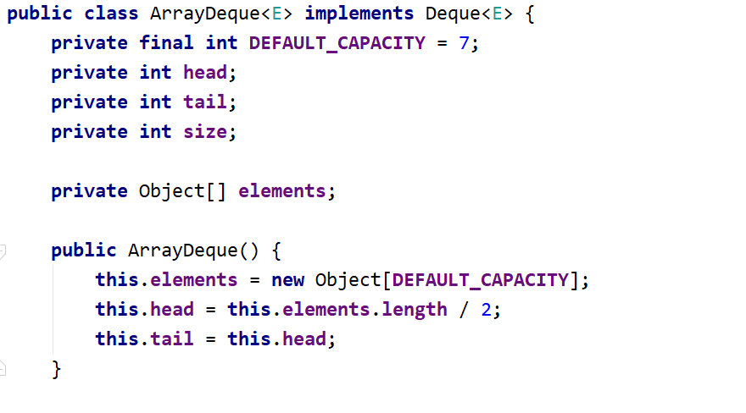

That is all the help you need the rest is on you and of course as **always** you are going to **make it**.

## ReversedList

Implement a data structure ReversedList<E> that holds a sequence of elements of generic type E. It should hold a **sequence of items in reversed order**. The structure should have some **capacity** that **grows twice** when it is filled, **always starting at 2**. The reversed list should support the following operations:

* Add(E element) – adds an element to the sequence (grow twice the underlying array to extend its capacity in case the capacity is full)
* Size() – returns the number of elements in the structure
* Capacity() – returns the capacity of the underlying array holding the elements of the structure
* Get(index) – the indexer should access the elements by **index** (in range 0 … size-1) in the reverse order of adding
* RemoveAt(index) – removes an element by **index** (in range 0 … size-1) in the reverse order of adding
* Iterator<E> – implement an iterator to allow iterating over the elements in a foreach loop in a reversed order of their addition

**Hint:** you can keep the elements in the order of their adding, by access them in reversed order (from end to start).

## Balanced Parentheses

Inside the **skeleton** you are given class **BalancedParentheses** and **BalancedParenthesesTest**. Your task is to **implement** the **method** **solve** **()** – which **performs** **analysis** of the **parentheses** filed and returns **true** or **false** whether the **parentheses** are **balanced** or **not**.

A sequence of parentheses **is balanced if** every open parenthesis can be paired uniquely with a closed parenthesis that occurs after the former. Also, **the interval between them must be balanced**.  
You will be given three types of parentheses: (, {, and [.

**{[()]}** - This is a balanced parenthesis.

**{[(])}** - This is not a balanced parenthesis.

"Wisdom comes from experience. Experience is often a result of lack of wisdom." ― Terry Pratchett